**Date Submitted: 9/26/2019**

**Task 00: Execute provided code**

**Youtube Link:** <https://www.youtube.com/watch?v=2t_qeYKDPTA>

**------------------------------------------------------------------------------------**

**Task 01:**

Youtube Link: <https://www.youtube.com/watch?v=NvNSERVzbSY>

**Current period of the LED blinking (Original code)**

$$\frac{40MHz}{2MHz}=20$$

**On-time of the LED blinking (Original code)**

$\frac{3}{20}=0.15 seconds$

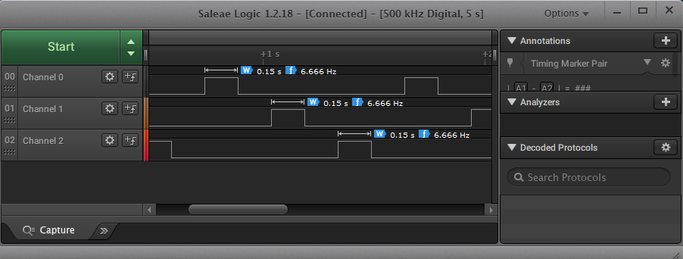

**Modified Code 1:**

**#include** <stdint.h>

**#include** <stdbool.h>

**#include** "inc/hw_types.h"

**#include** "inc/hw_memmap.h"

**#include** "driverlib/sysctl.h"

**#include** "driverlib/gpio.h"

uint8_t ui8PinData=2;

**int** **main**(**void**)

{

**SysCtlClockSet**(SYSCTL_SYSDIV_5|SYSCTL_USE_PLL|SYSCTL_XTAL_16MHZ|SYSCTL_OSC_MAIN);

**SysCtlPeripheralEnable**(SYSCTL_PERIPH_GPIOF);

**GPIOPinTypeGPIOOutput**(GPIO_PORTF_BASE, GPIO_PIN_1|GPIO_PIN_2|GPIO_PIN_3);

**while**(1)

{

**GPIOPinWrite**(GPIO_PORTF_BASE, GPIO_PIN_1|GPIO_PIN_2|GPIO_PIN_3, ui8PinData);

**SysCtlDelay**(2000000);

**GPIOPinWrite**(GPIO_PORTF_BASE, GPIO_PIN_1|GPIO_PIN_2|GPIO_PIN_3, 0x00);

**SysCtlDelay**(2000000);

**if**(ui8PinData==8){ui8PinData=2;} **else** {ui8PinData*=2;}

}

}

**Current period of the LED blinking (Modified code)**

$0.5seconds=\frac{3}{x}→x=6$

**On-time of the LED blinking (Modified code)**

$$\frac{40MHz}{y}=6→y=6.66667$$

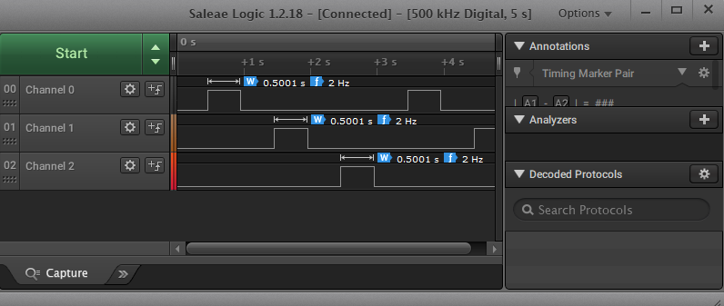

**Modified Code 2:**

// Task 1

**#include** <stdint.h>

**#include** <stdbool.h>

**#include** "inc/hw_types.h"

**#include** "inc/hw_memmap.h"

**#include** "driverlib/sysctl.h"

**#include** "driverlib/gpio.h"

uint8_t ui8PinData=2;

**int** **main**(**void**)

{

**SysCtlClockSet**(SYSCTL_SYSDIV_5|SYSCTL_USE_PLL|SYSCTL_XTAL_16MHZ|SYSCTL_OSC_MAIN);

**SysCtlPeripheralEnable**(SYSCTL_PERIPH_GPIOF);

**GPIOPinTypeGPIOOutput**(GPIO_PORTF_BASE, GPIO_PIN_1|GPIO_PIN_2|GPIO_PIN_3);

**while**(1)

{

**GPIOPinWrite**(GPIO_PORTF_BASE, GPIO_PIN_1|GPIO_PIN_2|GPIO_PIN_3, ui8PinData);

**SysCtlDelay**(6666666);// approx 0.5 seconds

**GPIOPinWrite**(GPIO_PORTF_BASE, GPIO_PIN_1|GPIO_PIN_2|GPIO_PIN_3, 0x00);

**SysCtlDelay**(6666666);// approx 0.5 seconds

**if**(ui8PinData==8){ui8PinData=2;} **else** {ui8PinData*=2;}

}

}

**------------------------------------------------------------------------------------**

**Task 02a:**

Youtube Link: <https://www.youtube.com/watch?v=Q8bh5NhkhU4>

**Modified Code:**

// Task 2a

**#include** <stdint.h>

**#include** <stdbool.h>

**#include** "inc/hw_types.h"

**#include** "inc/hw_memmap.h"

**#include** "driverlib/sysctl.h"

**#include** "driverlib/gpio.h"

// pin1 = r

// pin2 = b

// pin3 = g

//uint8_t ui8PinData=2; 001 0 -> r

//uint8_t ui8PinData=4; 010 0 -> b

//uint8_t ui8PinData=8; 100 0 -> g

// B G R

// 4,8,2

**int** **main**(**void**)

{

uint8_t ui8PinData=4;

**SysCtlClockSet**(SYSCTL_SYSDIV_5|SYSCTL_USE_PLL|SYSCTL_XTAL_16MHZ|SYSCTL_OSC_MAIN);

**SysCtlPeripheralEnable**(SYSCTL_PERIPH_GPIOF);

**GPIOPinTypeGPIOOutput**(GPIO_PORTF_BASE, GPIO_PIN_1|GPIO_PIN_2|GPIO_PIN_3);

**while**(1)

{

**GPIOPinWrite**(GPIO_PORTF_BASE, GPIO_PIN_1|GPIO_PIN_2 |GPIO_PIN_3, ui8PinData);

**SysCtlDelay**(10000000); // made delay slower to see the colors

**GPIOPinWrite**(GPIO_PORTF_BASE, GPIO_PIN_1|GPIO_PIN_2|GPIO_PIN_3, 0x00);

**SysCtlDelay**(10000000); // made delay slower to see the colors

**if**(ui8PinData==8) {ui8PinData=2;} **else** {ui8PinData*=2;}

}

}

**Task 02b:**

Youtube Link: <https://www.youtube.com/watch?v=na7ScNuCmeg>

// Task 2b

**#include** <stdint.h>

**#include** <stdbool.h>

**#include** "inc/hw_types.h"

**#include** "inc/hw_memmap.h"

**#include** "driverlib/sysctl.h"

**#include** "driverlib/gpio.h"

// pin1 = r

// pin2 = b

// pin3 = g

// uint8_t ui8PinData=2; 001 0 -> r

// uint8_t ui8PinData=4; 010 0 -> b

// uint8_t ui8PinData=8; 100 0 -> g

uint8_t ui8PinData=1;

**int** **main**(**void**)

{

**SysCtlClockSet**(SYSCTL_SYSDIV_5|SYSCTL_USE_PLL|SYSCTL_XTAL_16MHZ|SYSCTL_OSC_MAIN);

**SysCtlPeripheralEnable**(SYSCTL_PERIPH_GPIOF);

**GPIOPinTypeGPIOOutput**(GPIO_PORTF_BASE, GPIO_PIN_1|GPIO_PIN_2|GPIO_PIN_3);

**while**(1)

{

**while**(ui8PinData<10)

{

ui8PinData *= 2; // R,G,B

**GPIOPinWrite**(GPIO_PORTF_BASE, GPIO_PIN_1|GPIO_PIN_2|GPIO_PIN_3, ui8PinData);

**SysCtlDelay**(10000000);

**GPIOPinWrite**(GPIO_PORTF_BASE, GPIO_PIN_1|GPIO_PIN_2|GPIO_PIN_3, 0x00);

**SysCtlDelay**(10000000);

**if**(ui8PinData==4){ui8PinData=10;} // once it reaches to 4 it will exit the loop

**if**(ui8PinData==2){ui8PinData*=2;}

**if**(ui8PinData==8){ui8PinData=2;}

}

ui8PinData = 8;

**while** (ui8PinData < 16)

{

/*

(sequence of blinking with delay – R, G, B, RG, RB, GB, RGB, R, G, …)

R = 0010 = 2

B = 0100 = 4

G = 1000 = 8

RG = 1010 = 10

RB = 0110 = 6

GB = 1100 = 12

RBG = 1110 = 14

*/

ui8PinData +=2; // starts at RG

**GPIOPinWrite**(GPIO_PORTF_BASE, GPIO_PIN_3|GPIO_PIN_2|GPIO_PIN_1,ui8PinData);

**SysCtlDelay**(10000000);

**GPIOPinWrite**(GPIO_PORTF_BASE, GPIO_PIN_3|GPIO_PIN_2|GPIO_PIN_1, 0x00);

**SysCtlDelay**(10000000);

**if** (ui8PinData == 14) {ui8PinData +=2;}

**if** (ui8PinData == 10){ui8PinData = 4;}

**if** (ui8PinData == 6) {ui8PinData = 10;}

}

ui8PinData = 1; // reinitialize

}

}

**------------------------------------------------------------------------------------**